

**2020**

**UNHCR Syria Operation Billing System Project (Beta/Draft)**

**Project Documentation**

Syria ICT UNIT – Applications Support

Contents

Revision History 2

Service request, Operational and Business Requirements 3

Request Analysis 3

Access the system 3

Process the bill 3

Technical Support 3

Known Issues 3

# Revision History

|  |  |  |  |
| --- | --- | --- | --- |
| Date | Version | Description | Author |
| 13 September 2020 | 0.1 | Draft | Amer Karkoush |

# Service request, Operational and Business Requirements

# Request Analysis

User Documentation

# Access the system

**Step 1**: Enter the URL <https://beta.unhcrsyria.org/> into your browser and fill in your username and password (same as when you log on to your computer).

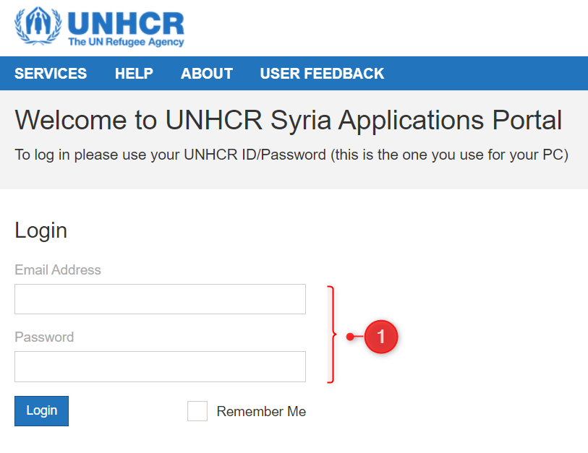

**Step 2**: Navigate to “**Telephony Billing**”.

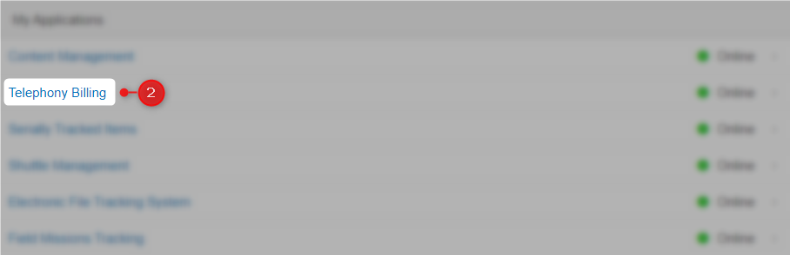

**Step 3**: Application’s home screen:

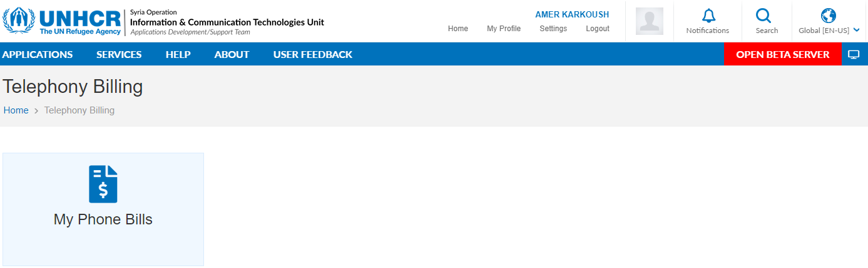

My Phone Bills: View your current and historical bills, identify private/official phone calls.

# Process the bill

Once your mobile bill is ready and uploaded into the system, you will receive an email notification for further processing and identifying private/official calls.

**Step 1**: Click the link that you received by email.

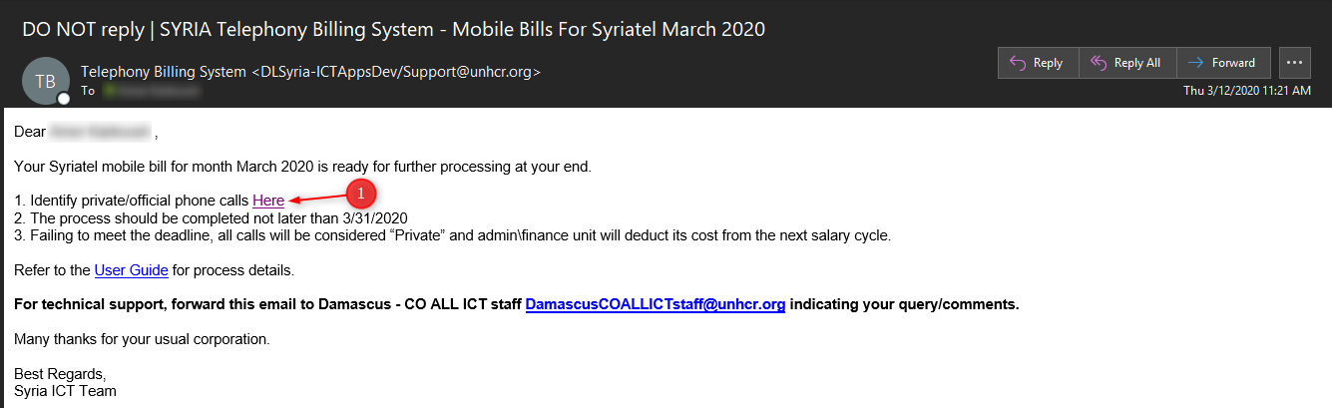

You can get back to the bill also by navigating to “My Phone Bills” from the application home page, then click on the relevant record.

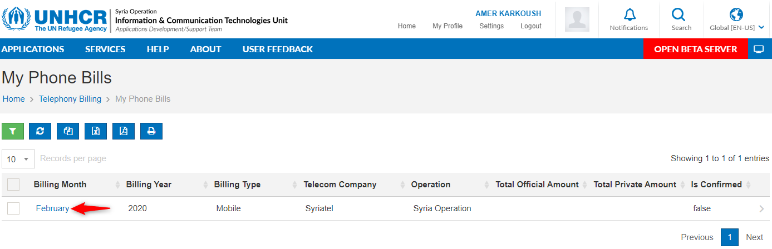

**Step 2**: Start identifying records as private/official by clicking below buttons

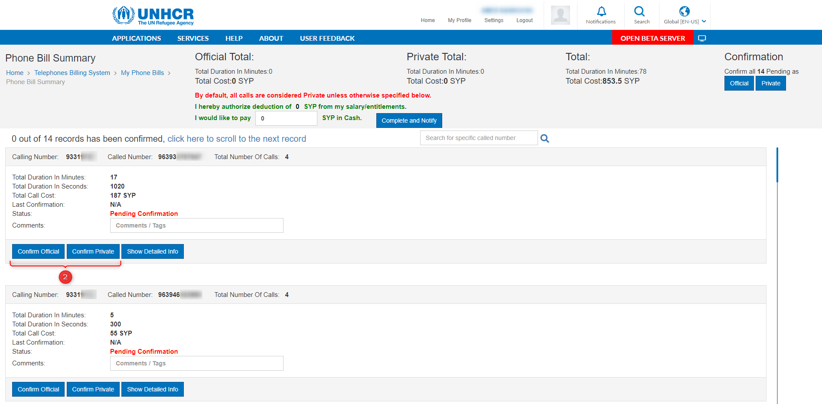

Each time a record is set, the system will begin to automate the following:

1. Auto calculation for officail/private totals.
2. The system will show you how much records confirmed out of total.
3. The system will keep learning from your historical identifications, and will help you identifying by showing/auto select the last confirmation for each called number (if exists). If the called number is UNHCR staff, the system will display the name of the staff who have been contacted. Comment field is for the staff reference for better tracking for future bills.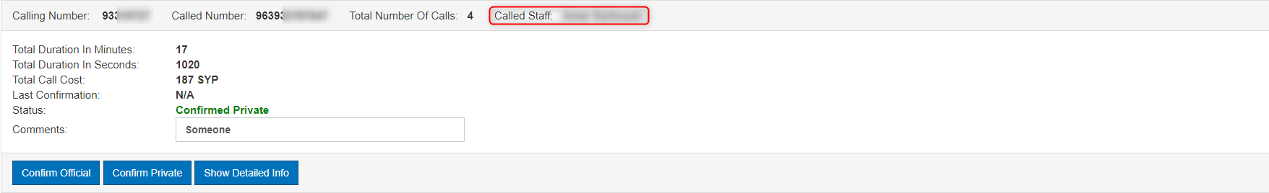
4. Section D will show you how many records are still pending to identify them, Click Official or Private to mark all pending as choosen. (The entire bill can be marked as private or official if there is no records marked manually)
5. Once there are no more records pending for identifying, section E is based on “Private cost”.

By default, the total private amount will be deducted from the next salary cycle.

If you prefere to pay in cash, fill the relevant field.

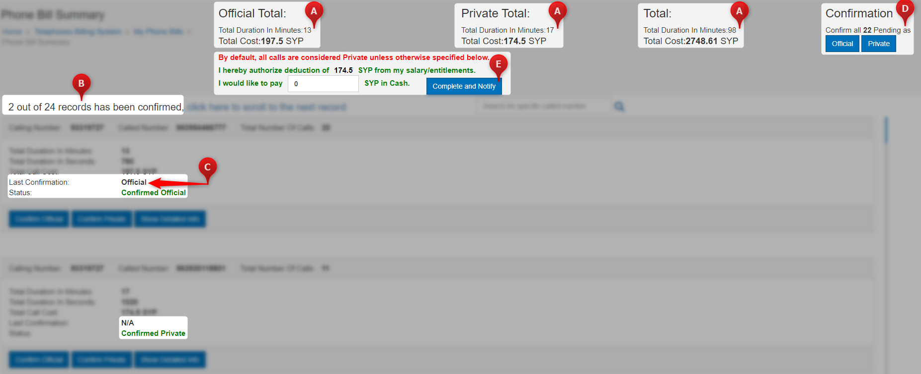

**Step 3**: To finalize the bill, click on  then .

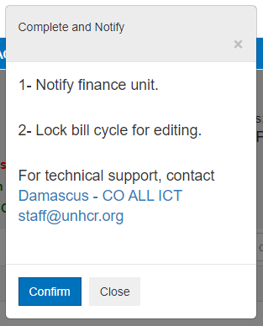

**Step 4**: After confirming , bill summary excel receipt will popup for download.

# Technical Support

All technical issues and requests should be addressed to:

**Syria - Apps Dev/Support <DLSyria-AppsDev/Support@unhcr.org>**

# Known Issues